Hosting
a Council of Governors Meeting

Hosting a COG meeting is the sole responsibility of the Sub-District and their participating Clubs.

Revision Date: November 13, 2023
Cal Refresh Committee 2022-2023
Council of Governors 2023-2024

Table of Contents
Hosting a Council Meeting 3
General 3
Council of Governors Meetings Defined 3
Site Selection 3
Application 3
Planning Preparation 4
Contracting 5
Negotiating – Getting the Best Deal 5
Contracts 5
Hotel Contracts 6
Meals 6
Hospitality 6
Budget for Hosting a Meeting 7
Miscellaneous 7
Getting Started 7
Preplanning 7
Budgeting 8
Booking 8
Planning Your Meeting 9
Food & Beverage 9
Meeting Details 11
Enhancing Your Meeting's Value 11
Preparing for Unexpected Situations 11
Post-Meeting/Follow-Up 11
Appendix 1 – Sample Room Layouts 12
Appendix 2: Sample Agenda and Schedule 14
Appendix 3: Council of Governors Planning Figures 17
Appendix 4: COG Equipment Requirements 18
Appendix 5: COG Planning Register 19
Appendix 5: COG Volunteer Requirements 21
Appendix 6: Application to Host a COG 22

Hosting a Council Meeting

General
Why host a COG? – The Council of Governors’ meetings are four opportunities for our leadership to gather together to review and discuss the state of the multiple district, share ideas for service, and identify areas for improvement and support. It also provides opportunities for district leadership to accomplish the following:
- Promote their District.
- Show other District Governors hospitality by being their host.

Council of Governors Meetings Defined
There are four Council of Governors meetings throughout the year, and all have a different focus.
- Organizational Meeting: This is the first COG of the year and is focused on organizing our efforts. It occurs on the 1st weekend in August and is relatively large. All committees meet to establish their yearly action plans and require meeting space. Several small and large meeting rooms are needed.
- Fall Meeting: This meeting is focused on establishing the budget for the next Lions year and all proposed Constitution and Bylaws changes in preparation for our election in February. This meeting occurs in late October or early November. This is a relatively small event and at times may be considered for a virtual/hybrid venue.
- Mid-Winter Meeting: This meeting is done in conjunction with our MD4 Convention and occurs the two days just prior to the MD-4 Convention (Wednesday and Thursday). The focus of this meeting is internal administration of the Multiple District, reviewing resolutions, selecting the MD4 auditor, and site selection for next year’s council meetings.
- Joint Meeting: This is the largest COG of the year. It includes four councils (three current year and the 2VDGE) and some committees. This meeting includes an orientation for VDGEs and DGEs and requires small meeting rooms. Additionally, this event provides the venue for the final Student Speakers Contest.

Site Selection
The site selection for the Organizational, Fall, and Joint COGs are determined by the current year Vice District Governors no later than the February COG meeting for the year that they will be governor. The Mid-Winter COG meeting is held just prior to the MD-4 Convention and is the responsibility of the convention hosting district. The Immediate Past Governors selected the August meeting. The 1VDGs will in turn select the site for the August meeting of the following year.
Note: It is recommended that the June meeting rotate from Area to Area each year in sequence if possible: that is, Area 1, then Area 2, then Area 3, then Area 4.

Application
Districts wishing to host a COG should fill out the application (Appendix 6) and present it to the council for approval no later than February 1. Be mindful that up charges are to only cover the comp meals and not to make a profit. The cost of each COG is increasing year over year. Every effort should be made to keep costs down.

Planning Preparation
- Decide which council of governors meeting you would like to host:
- “Organizational” First weekend in August.
- “Fall” in October/November.
- “Mid-Winter” in February is tied together with the MD4 convention, but separate.
- “Joint” in May/June is the largest with 4 councils and Student Speakers final contest.
- Attendance is based on which committees are meeting. Refer to the MD4 directory for a list of committees and chairs. All committee members attend the Organizational Council of Governor’s meeting.
- Create a committee (minimum of 3 people) with one person as the chair. Ask for a meeting schedule from that committee chair and step back and let them lead the effort providing input where needed. Recommended frequency is monthly initially, then moving to a more frequent schedule as you approach the event.
- The committee should investigate several locations that would be convenient for travel, housing, and size. (Helms Briscoe can assist with this effort at no cost to the District host.)
  - Contact the venue sales management with dates of your event, let them know that you are shopping for the best possible package they can arrange.
    - The amount of meeting rooms needed you are looking for the phrase “run of the house” (you may use copy of prior COG agenda)
    - The number of room nights needed for your block (possibly Wednesday, Thursday, Friday, and Saturday nights.
    - These costs should be what a travel agent gets when looking for rooms let them know that you plan to do an override after they have quoted the price which would be applied (to your food bill) you need these funds to pay for your possible entertainment and other expenses.
    - Keep in mind that it is typical practice for hotels to allow one free room for every 40 room nights. This room(s) could be used for your international guest or other visiting dignitary.
    - There should be no comps since everyone gets rules of reimbursement/audit.
    - For planning, with 3 councils you will have 45 room nights, council chair, MD4 secretary MD4 treasurer, and maybe 1 or 2 other guests, plus committee chairmen who are scheduled to meet.
    - Do not overbook your block as you will usually have to make an 80% payment or pay for them yourself.
    - Don’t be afraid to go to another venue to shop their prices.
  - Try to hold costs down as much as possible. Possibly look at a lunch menu for dinner, you could set a budget and let the chef put together some ideas. Ensure the meal prices are inclusive to eliminate the need to upcharge to cover room rental and service fees. Registration fees may be charged to cover the room rental and service fees.
- Don’t make any commitments until all the details are worked out. Other items to consider for booking the venue are:
  - Free parking, Wi-Fi, signage throughout the building, registration location, additional tables for registration, exhibit space, cost of coffee microphone and podium, (2 needed for business session)
  - Room availability, complimentary and paid—hospitality, committee meeting rooms, council business session rooms.
  - The room nights, the amount of food and beverages purchased are all to be used as bargaining chips in this negotiation.
- After you have chosen your food menu it is time to put together your registration form, with possible theme name, meal choices with prices, making certain that you have a section for any dietary needs.
- Your committee should include a registration chair to handle all registrations leading up to and at the time of the event.
  - Have all applications sent, with payments, to the designated committee chairperson. Use an electronic registration application whenever possible to collect registrations and payment.
  - Checks should be made to your district number with reference to the COG.
  - Due date and cut-off should be listed, generally, 10 to 14 days prior to event. Food orders after that date should become the chef’s choice.
  - Only turn in your food count that you have reservations for. That is all you will be paying for, once the count is turned in you might be able to add but you cannot subtract.
  - Boldly print venue name, location, phone number, e-mail, your event code, along with your cut-off date on your registration form and registration site.
  - Rooms kept after cut-off date, if you don’t drop them, you may be forced to pay for them as these are the responsibility of the hosting district.
  - Develop and print food tickets (venue is to be told that they must pick them up). Possibly use ink stamps to enter the meal rooms as an alternative.
  - Develop a registration roster make 3 copies of each registration (this allows for receipt for rules of audit). Place receipt and meal tickets into envelopes to give out when attendees arrive and pick up their registration packets.

Contracting

Negotiating – Getting the Best Deal
- Schedule negotiations early, ideally six months or more in advance.
- Prioritize what's truly important for your group's success before you enter into the negotiations.
- Ask about the facility's peak, off-peak and shoulder seasons, and the days of the week on which it would prefer to book business. If your meeting dates are flexible, you may be able to shift to a time slot providing greater leverage.
- Be aware that hotels typically give one complimentary room night for every 50 rooms occupied. (Every hotel’s minimum may vary)
- Consider upgrades and/or special amenities and services as important as negotiating dollar savings. For example, upgrading VIPs/special guests to Executive Level rooms or suites at the group rate might be more important than obtaining a greater percentage off the room rate.

Contracts
  - Make sure your contract covers all contingencies, such as incomplete renovations or properties that don't open as scheduled.
  - Ask to see a facility's standard contract, noting deposit, payment, attrition, and termination and cancellation policies. Negotiate a final agreement that incorporates their standard language, your organization’s requirements, and the negotiated agreement.
  - Make sure you have a binding contract. To be enforceable, a contract must specify definite terms, be accepted by both sides, and be signed by people with authority to enter into the agreement. A deposit is required to make the contract enforceable.
  - Check into any additional costs that may occur due to attrition or shortfall in revenue. Attrition, sometimes referred to as "slippage," can be applied to sleeping rooms and to food and beverage events.
A conference facility, having protected space for your meeting, may be due financial remuneration if your group does not perform as expected.
  - Look for termination clauses, often referred to as "Acts of God" clauses that apply when a meeting is stopped because of forces beyond the control of the group or the facility. Generally, there are no penalties assessed to either party in these circumstances.

Hotel Contracts
- Guarantees for rooms - Recommend using conservative numbers for guarantees on the number of hotel rooms. Make sure reservations will be accepted at least up to two weeks prior to the meeting. The number of complementary rooms are usually tied to the overall room night block.
- Complimentary rooms - When possible, provide one suite for the council chair and a suite for hosting governor, and one suite for the current or immediate past international officer. If an international guest is invited an additional suite needs to be reserved. If the hotel will not give suites, but will only give complementary rooms, try to negotiate a small fee for upgrade to suite. Hosting District may cover this cost if possible.
- Meeting rooms - There should be no charge for meeting room space. Meeting space is usually based upon room block and number of meals taken at the hotel. Consider asking for corporate sponsorship for rooms if not complimentary. Each meeting room should have one microphone, a screen, and projector (district provided or by the venue). AV Expenses should be covered by the registration fees charged to attendees, including the Student Speaker contest. See the Policy and Procedures Manual.

- Refreshments - Water should be provided during the council caucus and business sessions.
- Corkage - Check the contract and make sure that the hotel will allow you to serve cocktails and food out of a suite with no charge. Generally, a hotel will not permit this out of one of their meeting rooms without a charge or not at all.
- Penalties - Check the contract for penalties that may be imposed if you do not meet your room night or meal commitments.

Meals – (Dietary restrictions need to be include in the planning)
- Lunches - Usually planned at the hotel on days when the council is meeting. It is preferable to keep these menus lighter, such as soup and salad, sandwiches, a deli buffet, pasta salad, etc. Skipping desert can decrease the cost.
- Dinner - The first night typically is outside the hotel with each council meeting independently. The hosting governor and vice governors make arrangements for their own council at a local restaurant. Be creative in your approach. Other alternatives may include: an outdoor barbecue by a local Lions club; dinner at a blind center or other facility owned by a district supported project. The second dinner would be focused on bringing all councils together. This may be at the host hotel. Entertainment for this event is welcomed. (Factor this cost into your budget). It is customary to comp meals for current sitting dignitaries if possible: IP, ID, CC.
- Reservations - Someone from the hosting district should be appointed to receive all meal reservations (including any dietary restrictions). Entire meal description should be on the registration forms. It is best to deposit this money in A NEW account and then pay the hotel or restaurant with a check from that account. Meal tickets are the responsibility of the hosting district. Keep a careful count on meal tickets sold, the guarantee given to the hotel, and the number of additional meals the hotel can provide at the last moment. Make sure the room is set for the correct number.

Hospitality
- The hosting district is responsible for providing a hospitality room prior to dinner each night during the weekend. Many districts ask local clubs to participate and provide some of the goodies as well as servers. Factor the costs of the liquor, ice, glasses, etc. into the budget for the meeting.
- Welcome gifts - It is a nice gesture from the hosting district to provide hospitality gifts to the DGs, the vice governors along with any current or past international officers. Usually, donated items can be obtained. Be sure to provide for this in your budget.

Budget for Hosting a Meeting
- Income - Income is generated through the registration fee, corporate sponsorship, or the hosting district’s fundraising. Some districts have a miscellaneous account that may be used, or the district governor may have a discretionary account. Keep accurate records, Excel spreadsheets work well.
- Check with the B&F committee first: MD-4 may provide budgeted expenses for the Committee’s extra costs. YOU MUST GET PRIOR APPROVAL FROM THE COUNCIL CHAIR FOR USE.
- It is not cost effective to host a meeting where the hotel is charging for meeting room space or AV equipment. The MD does have AV equipment for our meetings available for use. Look for another hotel or venue. Transportation (bus) to an off-site restaurant is typically expensive. Use carpooling or try an alternative site for the meal.

Miscellaneous
- The hosting governor and perhaps one other Lion should be the only people with the authority to change an arrangement or add something during the council meeting. This will provide better control over the entire function and avoid additional financial charges.
- The hosting governor should be prepared to take an active role in the entire function. The governor may appoint another Lion to negotiate arrangements with the hotel or assist with the planning. Try to request low fees or freebees like parking, coffee, internet, easels, AV, re-setups of rooms, etc. If they say the price is $X, suggest a lower fee and meet halfway. Remind the hotel that Lions are nonprofit and helping communities. Ask the hotel or venue to be a sponsor of the event as well.
- If you bid to host an August meeting be aware that you will not be governor at the time of that meeting. It is best if you consult with the vice governor this year and if that Lion is willing to be the host governor for an August meeting. This will help ensure that the meeting will run smoothly.
- Public Relations/Marketing - This is your party, so if you want a greater attendance, spread the word, call the councils and committee members, request they promote in their district and other meetings, send e-mail, post on websites.

Getting Started

Preplanning
  - Submit your application to host a COG to the Council Chair.
  - Establish your COG planning committee. Assign specified tasks to each member of the committee.
  - Consider the size of the group and any special needs.
  - Determine meeting dates including general timelines for the event. Avoid dates that coincide with other events or holidays.
  - If the dates conflict with a local event, holiday, or hotel availability, the host district must coordinate with the council to adjust current mandated COG dates by our bylaws.
  - Plan the meeting or event in advance to secure the most desirable space.
  - Obtain the agenda outline from the Council Chair for each session or activity, including expected attendance, seating arrangements, required setup, starting, and ending times, and audiovisual and production needs.
  - List food and beverage requirements for each occasion, including meals, receptions, and breaks.
  - Consider air and ground transportation needs.
  - Plan entertainment and recreation needs, group activities and/or team-building exercises.
  - Prepare a timeline for producing invitations, event promotion, registration, and production of meeting materials.
  - Designate an administrative person to create name badges and coordinate written material.
  - Budget for all sponsor expenses and calculate expenses for meeting participants.
  - Schedule speaker(s), if required.

Budgeting
  - Determine which expenses will be assumed by the meeting or event sponsor and by the attendees.
  - Create a balance sheet listing expenses for all functional areas of your meeting or event, such as staff time, marketing expenses, air and ground transportation, accommodations,
  - Food and beverage, entertainment and recreation, taxes and gratuities, service charges, audiovisual equipment, and production costs.
  - Build a contingency fund for unanticipated expenses.
  - Don't forget expenses for licenses (music, written materials) and insurance (liquor and general liability, business cancellation and interruption).
  - Check budgets from similar meetings and events to gauge cost.
  - Make sure funds are allocated to pay all suppliers. Establish a holding account for accrued program expenses.
  - Consult with your District’s finance committee or Cabinet Treasurer on formatting the budget.
  - Secure the signature of the District Governor or other person with fiscal responsibility in your District, for any expenditures above what you have budgeted.

Booking
- Selecting a Destination
- Determine if there are any goals or needs that might make a particular destination more preferable.
- Choose a convenient location based on where your guests are traveling from, their travel time and cost to reach a destination, and a site near air and/or ground transportation.
- Be aware of seasonal hotel occupancy rates, room taxes, and recent changes in supply or demand that will affect your expenses. Schedule around big conventions or festivals that could limit hotel room supply and services during your meeting or event dates.
- Check flight schedules/frequency to your destination - most participants prefer direct, nonstop flights.
- Consider factors such as weather, security, political/social climate, and labor considerations that may affect participation and/or costs of the event.
- Finding the Right Hotel
- Determine the type of hotel that will best suit your meeting or event needs (an airport hotel, convention and meeting hotel, resort, conference center or all-suite hotel).
- Determine the type and number of guest rooms needed (singles, doubles, suites, specially equipped business rooms or rooms accessible for people with special needs.)
- Determine the number and size of meeting rooms needed; use past programs as a benchmark.
- Choose a hotel with facilities that meet your needs, such as sleeping and meeting rooms, restaurants, sightseeing and recreation options.
- Keep in mind the comfort of your attendees. Consider hotel services that will enhance the stay of special guests or VIPs.
- Submitting Meeting or Event Specifications or a Request for Proposal (RFP)
- After the preliminary research is complete, create a Request for Proposal (RFP). This allows the venue management to see, in writing, the information about your group.
- Preparing the specifications is a valuable process because it requires you to think about all the needs of the group. Be sure to document all site requirements, including:
    - Preferred dates and optional dates (if available).
    - Number and types of guest rooms.
    - Number, size and usage of meeting rooms and the times they are needed.
    - Range of acceptable rates.
    - Dates and types of meal functions and breaks.
    - Exhibits and any other special events or activities.
    - Any related information such as complimentary requirements.
- Inspecting the Site
  - No facility will look the same in person as it will on paper, nor will you be able to get a sense of service without going to the site.:
  - Check with other people, including other planners, to see which properties they've used and which ones they would recommend.
  - Use the Internet to complete preliminary reviews of the sites, and/or contact the local convention and visitors' bureau for materials, including facility descriptions, city maps, transportation information, etc.

Planning Your Meeting

Food & Beverage
- Making Cost-Effective Choices
- Evaluate the cost and time savings for a small group to eat in a private section of the restaurant, as opposed to having a catered meal.
- Write out the due dates for guarantees. Typically, guarantees are due 1 week prior to the event.
- Specify the "overset" in the contract. An overset is the number of people beyond the guaranteed number for which the facility will set tables and places. This amount varies from 0 to 10% or more; the industry average is 5%.
- You will usually be billed for the guaranteed number, or the number served, whichever is greater.
- Find out what service charges and/or gratuities will be added to the price of the meal and taxed, to avoid any surprises.
- Don't compromise on quality. However, if your budget is restrictive, consider reducing the number of food functions you are planning for your meeting or event.
- Consider flowers, decorations, and entertainment. Your hotel can provide ideas for floral arrangements, table and room decor and quality entertainment.
- Planning the Meals
    - At events offering food and beverage service, allow enough time for guests to eat leisurely, network or socialize with colleagues or friends and family, and enjoy all presentations or ceremonies, if there are any involved.
    - Generally, allow 30 to 40 minutes for breakfast, 45 to 60 minutes for lunch, and 20 minutes per course for dinner. For refreshment breaks, allow a minimum of 15 minutes for up to 100 people.
    - Plan on two cups of coffee or tea per person for a morning break and one cup of coffee/tea or one soda per person during an afternoon break.
    - Consider a luncheon buffet for small group working sessions. Buffets offer variety and faster service.
    - Consider requesting one server for each table, for more formal meals and/or VIP tables.
    - Most facilities allow one server for every two tables, for standard, three- or four-course meals. Check with the facility to determine if there will be additional labor charges for the extra servers.
    - Always plan to serve a variety of foods during cocktail receptions.
    - Provide one bartender for every 75-100 people if a bar is planned.
    - Offer nonalcoholic beverages in addition to beer, wine, and premium liquor.
    - If the venue is provided by a Lions Club, consider donating leftover food to homeless shelters or distribution organizations for the needy.

- Meeting Room Setup/Configurations
- Conference and Hollow Square: Appropriate for interactive discussions and note-taking sessions for fewer than 25 people. Many hotels have elegant boardrooms for 10 to 20 people; equipped with full audiovisual capabilities, a writing board, cork board and a flip chart.
- E-shape, U-shape, and T-shape: Appropriate for groups of fewer than 40 people. These are best for interaction with a leader seated at the head of the setup. Audiovisual equipment is usually set up at the open end of the seating.
- Ovals and rounds: Generally used for meals and sessions involving small group discussions. A five-foot-round table seats eight people comfortably. A six-foot-round table seats 10 people comfortably.
- Theater: Appropriate for large sessions and short lectures that do not require extensive note taking. This is a convenient setup to use before breaking into discussion or role-playing groups because chairs can be moved.
- Schoolroom or Classroom: The most desirable setup for medium to large-size lectures. This configuration requires a relatively large room. Tables provide attendees with space for spreading out materials and taking notes.

- Audiovisual Equipment
- Be aware of factors that can directly affect the quality and cost of an AV presentation: ceiling height, walls, floors, obstructions, windows, lighting, mirrors, doors, air conditioning, and fire exits.
- Ask the AV representative to walk through the space with you. This person will be able to explain how to best use the meeting or event space.
- Communicate with speakers/presenters to confirm AV needs. Plan for a minimum of an overhead projector, screen, and flip chart(s) for smaller breakouts. More often, presenters are using computer LCD projectors and high-intensity overheads. Determine the availability and cost of this equipment.
- Be aware that all rooms are not equipped with sound systems, nor do all sessions need sound. Determine which rooms need sound and which can be used with the systems in place. Try to negotiate a flat rate or a percentage off the daily rate when renting a system.
- Consider that screen height generally should be the distance from the screen to the back wall divided by eight; chairs should be no closer to the screen than 1.5 times the screen's height; ceilings should be at least 10 feet high. Rely on your AV technician for assistance.

Meeting Details

Enhancing Your Meeting's Value
- Meet during a period when the hotel’s business is slow.
- Schedule a meeting within a gap in the hotel’s schedule.
- Try selecting a hotel that’s new to the market or newly renovated; they often offer special rates to encourage business.

Preparing for Unexpected Situations
- Send your rooming list well in advance, at least seven to 30 days prior to arrival.
- Inform guests of the hotel's location and amenities.
- Send your meeting specifications to the hotel two to four weeks before a meeting. List every meeting requirement, day-by-day, hour-by-hour.
- Don't forget to reserve space for your meeting office, pressroom, and speaker-ready room.
- Check the Event Orders (EOs) and Banquet Event Orders (BEOs) from the hotel. Check against your specifications and advise the hotel promptly of any changes or of your approval.
- Hold a meeting 24 to 48 hours in advance of the meeting to review event expectations, procedures and to provide an opportunity to meet staff contacts who will help you with any problems.
- Never assume that a request has been taken care of - always double check.
- Work with the hotel to resolve any last-minute changes.
- Things to do daily:
  - First thing each morning, secure a printout of all rooms in house and a report of any "no- shows" or cancellations.
  - Early in the day, and again in the afternoon, meet with your hotel contact to review any changes in the program and/or meal counts.
  - Each afternoon, set aside time to meet with accounting to review the bills from the day before and verify that your charges are correct.

Post-Meeting/Follow-Up
- Hold a post meeting with the same people who attended the pre- meeting. Evaluate what worked and what did not; review the bills and ask for feedback immediately from the facility.
- Ask your attendees to provide feedback about the program content and format, meeting facility, speakers, meal functions and other special activities.
- Solicit feedback from the meeting sponsor. Write a meeting report and file it away and provide a copy to the Council Chair.
- File contracts for future meetings.
- Write thank-you letters to staff, speakers, hotel staff and other vendors.

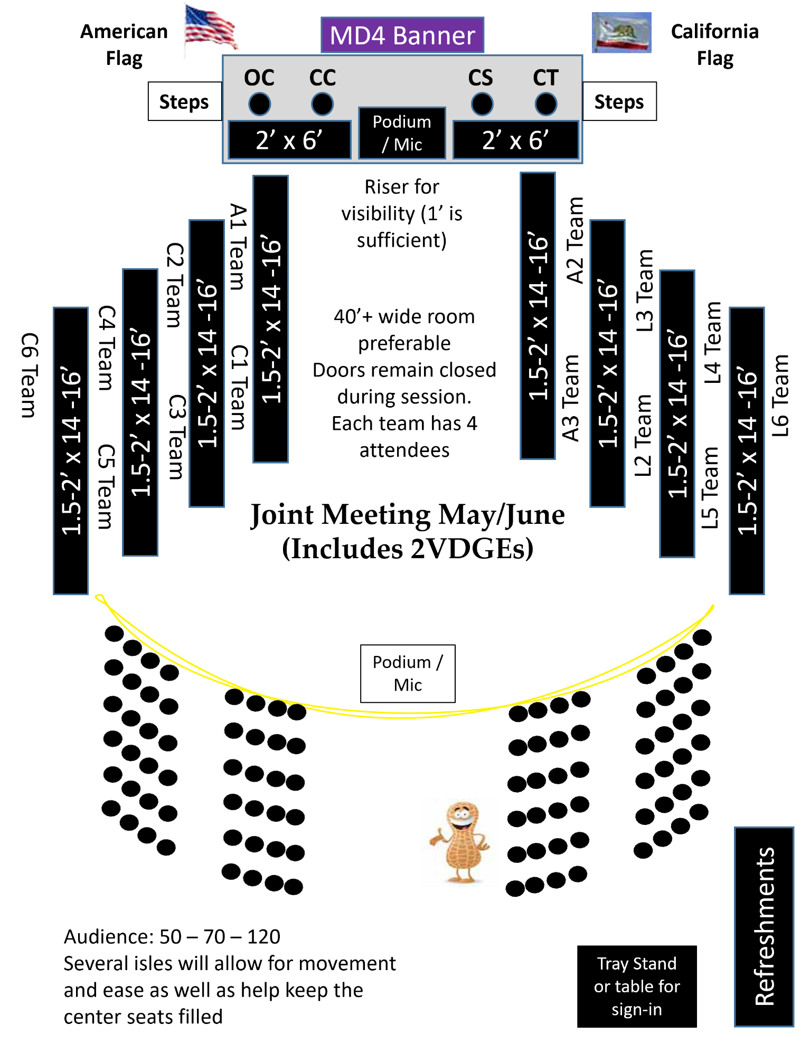
Appendix 1 – Sample Room Layouts
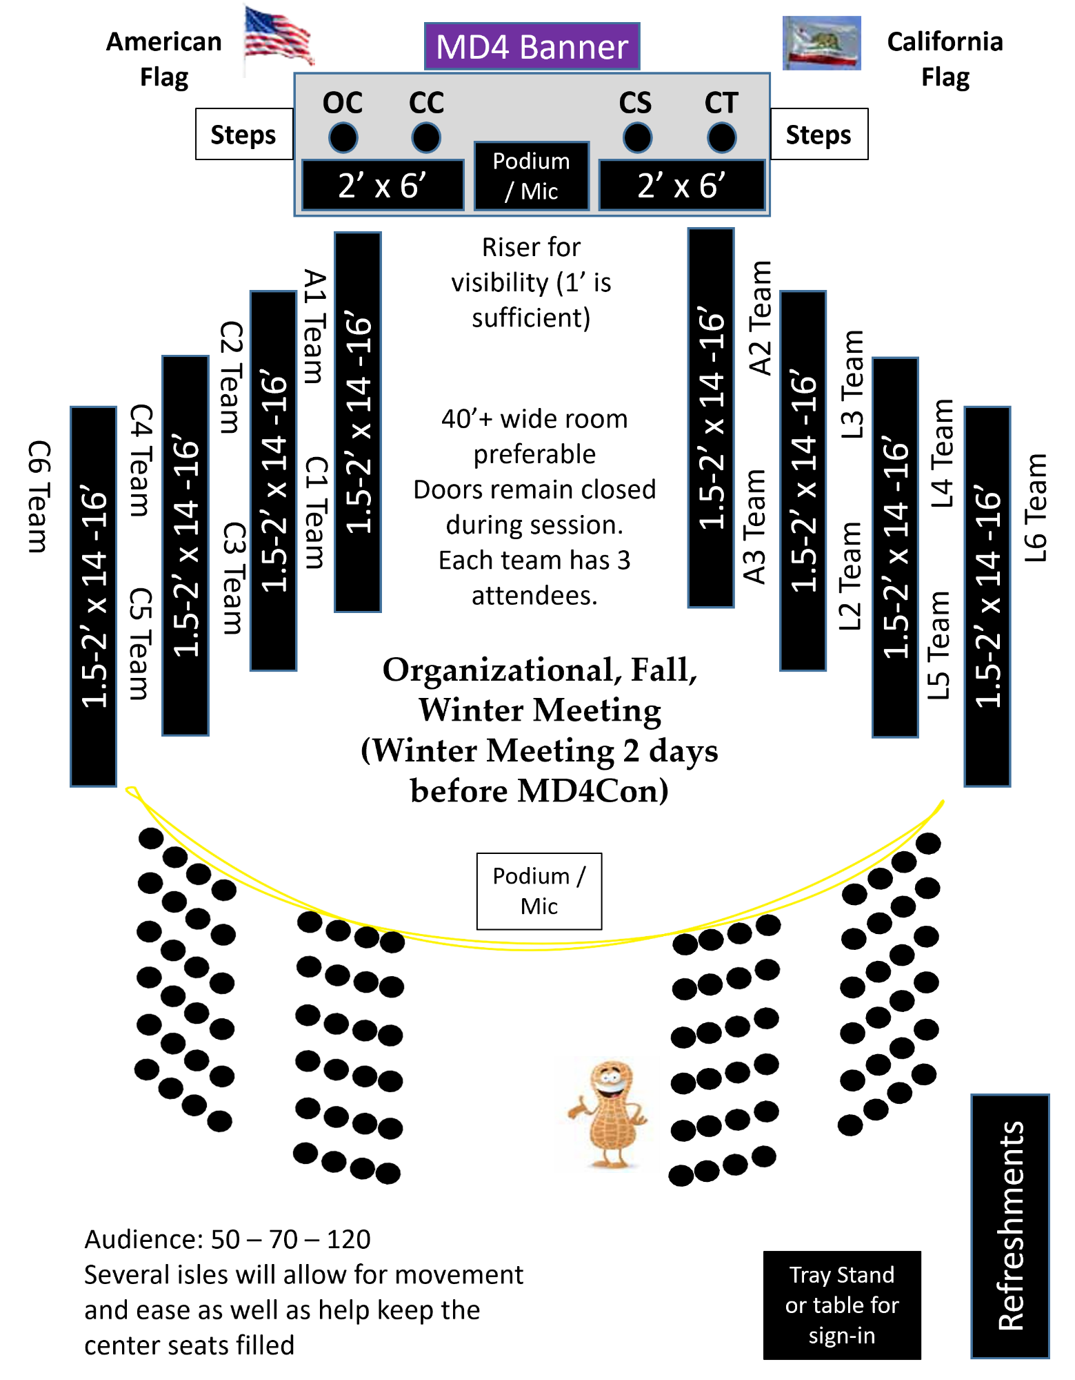

Appendix 2: Sample Agenda and Schedule

California Lions Clubs
Multiple District Four
Council of Governors
Organizational - Summer Meeting
August XX-XX, 20XX
2nd Vice District Governor GAT Training August XX, Thursday
“Theme”
Hosted by District Governor XXX, 4-XX at the Hotel Name
xxx
Please make checks payable to: District 4-xx Mail Reservations to: xxxxx
(xxx) xxx-xxxx
Deadline:
Room Reservations
(xxx) xxx-xxxx| www.xxxxxxxxxxxx.com
Mention Code: xxxx to receive discounted room rate of $xxxx.00 plus taxes Room price available Until xxxxxxxxx
For information, questions, etc., contact CT xxxx (xxx) xxx-xxxx or
xxxxxx@xxxxxx.com For complaints, call someone else.
****Scrapbooks – drop off at registration****

20XX-20XX COUNCIL OF GOVERNORS ORGANIZATIONAL MEETING
August X – August X, 20XX ● City, California

SCHEDULE
Thursday – August 1 (Business Casual Attire) Location
12:00 – 5:00 Registration/Office Room
8:00 – 5:00 GLT 2VDG Training (20 conference)
7:00 all days MD4 Office (8 conference)
Friday – August 2 (Council Business Casual Attire) Location
8:00 – 5:30 Registration/Office Room
8:00 – 9:00 DGs .................................................................................(20 conference) Room
8:00 – 9:00 1VDGs (20 conference)
8:00 – 9:00 2VDGs (20 conference)
8:30 – 11:00 Spouses & Partners (30 Rounds) Room
9:15 — 12:15 Committee Workshop (100 rounds of 8) Ballroom
Spread out so conversations don’t impede on each other.
9:15 – 11:30 California Lions Foundation Board Meeting...................(20 conference) Room 9:15 — 6:00 Scrapbook viewing (3 side tables for book viewing) Room
12:30 — 1:30 Lunch; Speaker xxxxxx (70-100 = Rounds of 8-10) Room

2:00 — 4:00 Council Caucus (head table of 17 podium/mic, theatre of 120) Ballroom
2:00 — 4:00 Partners Reception “xxxxxx” & Handbook Review (30 Rounds) Room
4:15 — 5:00 Executive meeting ...........................................................(8 conference) Room
5:00 — 6:30 CLF Auction ?? Suite #
5:30 — 6:30 Hospitality Presidential Suite #
7:00 — Dinner (70-100 = rounds of 8-10) room

Page 2 of 3

20XX-20XX COUNCIL OF GOVERNORS ORGANIZATIONAL MEETING
August X – August X, 20XX ● City, California

Saturday, August 3 (Council Uniform / Business Attire) Location
8:00 — 9:00 DGs (20 conference) room
8:00 — 9:00 1VDGs (20 conference) Room
8:00 — 9:00 2VDGs (20 conference) Room
9:15 — 12:15 Budget Committee Hearings (8 conference) Room
9:15 — 11:15 room
11:15 — 12:15 GAT Coordinator Interviews.................................................... (20 conference) Room
9:30 — 12:15 Student Speakers Topic Discussion (80 Theatre) Ballroom
9:00 — 12:15 Scrapbook viewing (A place to display books several tables lock up at PM) Room
If the spouses have a room to use all weekend it can be in there. However, the spouses won’t be in the room all day.
10:00 — 12:00 Partners Service Project TBD.........................................................................................
12:30 — 1:30 Lunch (70-100 = rounds of 8-10) room

2:00 — 4:00 Council Session I Special Setup w/ a theatre of 100 Ballroom
(After introductions, Partners and Student Speaker Chairs are excused.)
2:00 — 4:00 Partners Meeting Scrapbook Judging CLOSED (20 conference) Room
2:30 — 4:30 Student Speakers District Chair Training (20 conference) Room
4:00 — 5:00 Council meeting DGs (20 conference) Room
Student Speakers topic discussion selection
5:00 — 6:00 Executive Team Meeting (8 conference) Room
5:30 — 6:30 Hospitality Presidential Suite #
7:00 Dinner (70-100 = rounds of 8-10) room
Sunday, August 4 (Council Business Casual Attire) Location

9:00 — 11:00 Council Session II Special Setup w/ a theatre of 100 Ballroom
Adjournment Page 3 of 3

Appendix 3: Council of Governors Planning Figures
Council of Governors Meeting Planning Matrix
 | Attendees | Room Nights | Meals
International Director, Partner in Service | 2 | 3 | 8
Past International Director’s (3), Partners in Service (3) | 6 | 9 | 24
Council Chair (1), Partner in Service (1) | 2 | 3 | 8
Immediate Past Council Chair (1), Partner in Service (1) | 2 | 3 | 8
Office Coordinator | 1 | 4 | 4
District Governors (14), Partners in Service (8-10) | 23 | 46 | 92
1VDG (14), Partners in Service (5-10) | 20 | 40 | 80
2VDG (14), Partners in Service (5-10) | 20 | 40 | 80
Committee Chairs (30), Partners in Service (10) | 40 | 80 | 160
Student Speaker District Chairs (14), Partners in Service (5-10) | 20 | 40 | 80
Foundations:
LCIF Trustee, Partner in Service | 2 | 2 | 8
Student Speaker Foundation, Partner in Service | 2 | 2 | 8
California Lions Foundation, Partner in Service | 2 | 2 | 8
Lions Eye Foundation, Partner in Service | 2 | 2 | 8
Lions Float Inc, Partner in Service | 2 | 2 | 8
Totals | 140 | 272 | 538
The above are estimates only. Confirm attendance and adjust accordingly. Below are some planning considerations:
- Each couple accounts for one room night times two nights. IDs, PIDs, and CCs plan for three nights.
- Each person accounts for two meals per day. Breakfast is either complementary from the hotel or at their own expense.
- Estimates above are based on minimum attendance.

Appendix 4: COG Equipment Requirements
Every effort should be made to obtain the AV equipment, screens, projectors, extension cords, and power strips from the Venue at no cost. If the venue has an internal speaker system and projection screens, obtain the details to determine if it is compatible with MD4’s equipment thereby alleviating the need to transport our speakers and stands.
If unsuccessful in obtaining the venue resources, the host committee can help offset transportation requirements by providing any of the below equipment.
Ensure that the venue provides internet access for the duration of the COG. If not available or proves expensive, notify the MD4 Tech team for alternate hot spot options.

Item | Qty | Who Brings | Notes
Training Requirements:
Projector Screens | 2 ea | MD4 Tech | Try to get from hotel or host district
Projectors | 2 ea | MD4 Tech | Host district should have 2 for back up
Projector Cable | 2 ea | MD4 Tech
Power Cords | 2 ea | MD4 Tech
Extension Cords | 2 ea | MD4 Tech | Try to get from hotel or host district
Power Strips | 2 ea | MD4 Tech | Try to get from hotel or host district
For COG Meetings:
Audio Mixer w/ power cord | 1 ea | MD4 Tech
Microphone cables | 2 ea | MD4 Tech | Goes to podium mic
Microphones (wireless) | 2 ea | MD4 Tech | For room
Microphones (wired or wireless) | 2 ea | MD4 Tech | For podiums
Speaker Stands | 2 ea | MD4 Tech
Speakers w/ power cables | 2 ea | MD4 Tech
Projector screens | 2 ea | MD4 Tech | Try to get from hotel or host district
Podium | 2 ea | Host | Provided by Venue or Host District
For Admin Support:
Center podium banner | 1 ea | Council Chair
Banners behind podium |  | Council Chair
US Flag with pole and base | 1 ea | Host | Provided by Venue or Host District
CA Flag with pole and base | 1 ea | Host | Provided by Venue or Host District
Crates with nameplates | 1 ea | Council Chair
Boxes with Blue Books |  | Council Chair | Reports for Councils & Committees
Supplemental Handouts |  | Council Chair | As needed
Binder for daily attendance | 1 ea | Council Chair
Box for Rules of Audit | 1 ea | Council Chair
Audio recorders | 2 ea | Council Chair | To help with minutes

**Add an AV request form for host committee or MD committees to use.

Appendix 5: COG Planning Register

Task # | Task | Due Date | Status | Date Complete | Notes
1.0 | Determine COG to Host | 8/1/20XX |  |  | Discuss with Council during the Organizational COG
2.0 | Determine date of the event | 9/1/20XX
3.0 | Submit application | 2/1/20XX |  |  | Submit prior to Winter COG of the previous year
4.0 | Create Committee | COG-210 |  |  | Registration, Entertainment, Hospitality
5.0 | Identify potential sites (shop venues) | COG-180
5.1 | Identify # of Room Nights |  |  |  | Planning factor 50 room nights x # of nights base plus planned committee members
5.2 | Identify # of free rooms
5.3 | Identify complimentary rooms |  |  |  | Hospitality suite, committee rooms,
5.4 | Determine room rental fees |  |  |  | Are these separate or included if catering is purchased. Are there room set up fees
5.5 | Determine estimated headcount for meals
5.6 | Determine Wi-Fi, parking, tables(fees), etc.
5.7 | Collect menus and pricing |  |  |  | Include fees for wait staff, room set up, tax, gratuity
5.8 | Provide for coffee and water |  |  |  | Coffee and water in every meeting room.
6.0 | Select Site | COG-150
7.0 | Establish Budget line and Bank Account | COG-150
8.0 | Review and sign contract | COG-120
9.0 | Pay deposit | COG-120
10.0 | Determine Theme | COG-120
11.0 | Identify Entertainment Plan | COG-120
12.0 | Build Menu and get pricing | COG-120 |  |  | Ensure that service charges are a part of the meal charge
13.0 | Refreshments for all days planned & pricing | COG-120 |  |  | Coffee and water in every meeting room.
14.0 | Determine any room charges | COG-120 |  |  | Room, AV, tables, room configuration changes, etc. should be identified and planned for
15.0 | Book Entertainment | COG-120 |  |  | Ensure this cost is covered by the prices set for the event. Plan on entertainment for Friday and Saturday nights
16.0 | Determine Registration Fee | COG-120 |  |  | This fee should help with refreshments and admin requirements
17.0 | Determine if a collection will take place | COG-120 |  |  | School Supplies, Food
18.0 | Create Flyer and invitation | COG-120
19.0 | Meet with Council Chair for In process update | COG-120
20.0 | Set up Ticket Spice or registration site | COG-90
21.0 | Begin marketing and publication plan | COG-90
22.0 | Meet with Council Chair for In process update | COG-60
23.0 | Determine Partner in Service Event | COG-45 |  |  | Typically determined by the CC PIS & DG PIS.
24.0 | Determine Hospitality Requirements | COG-45
25.0 | Build Agenda | COG-30 |  |  | Done by CC
26.0 | Build Training Plan (if included) | COG-30 |  |  | Done by MD4 GLT
27.0 | Meet with Council Chair for In process update | COG-30
28.0 | Determine Council Dinner locations | COG-21 |  |  | Typically, on Thursday night-planned by hosting council
29.0 | Determine Goodie Bag Contents & Purchase | COG-21 |  |  | Can also ask clubs to donate items. Nice touch to make it specific to the area.
30.0 | Meet with Council Chair to Finalize Things | COG-14
31.0 | Provide venue with room set up diagram | COG-14
32.0 | Identify Volunteer Requirements | COG-14
33.0 | Build Registration Packets | COG-3
33.1 | Print Meal Tickets
33.2 | Print Agenda for Registration Packets
33.3 | 2 copies of Registration Receipts
33.4 | Purchase registration envelopes |  |  |  | 5x7 envelopes work well
34.0 | Build Goodie Bags for Attendees | COG-3
35.0 | Open Registration | COG-0 |  |  | Typically, on Weds night for VDG training

Appendix 5: COG Volunteer Requirements

Volunteer Requirements
Task | Time | # Vol | Volunteer | Volunteer | Volunteer | Volunteer
Registration Wednesday | 3:00 - 5:00 pm | 2
Registration & Support Thursday | 8:00 am - 11:00 am | 4
Registration & Support Thursday | 11:00 am to 2:00pm | 4
Registration & Support Thursday | 2:00 to 4:30 pm | 4
Registration & Support Friday | 8:00 am - 11:00 am | 4
Registration & Support Friday | 11:00 am to 2:00pm | 4
Registration & Support Friday | 2:00 to 4:30 pm | 3
Registration & Support Saturday | 8:00 am - 11:00 am | 2
Registration & Support Saturday | 11:00 am to 2:00pm | 2
Registration & Support Saturday | 2:00 to 4:30 pm | 2
Decorating on Saturday | 4:30 to 6:00 pm | 2
Transportation (Weds - Sunday) | Various | 4
Hospitality Suite Bartender (Thurs – Sat) | 4:30 pm to 11:00 pm | 2
Thursday Lunch Meal Ticket Collection | 12:00 pm to 12:15 pm | 1
Friday Lunch Meal Ticket Collection | 12:00 pm - 1:00 pm | 1
Friday Dinner Meal Ticket Collection | 6:00 pm - 7:00 pm | 1
Saturday Lunch Meal Ticket Collection | 12:00 pm - 1:00 pm | 1
Saturday Dinner Meal Ticket Collection | 6:00 pm - 7:00 pm | 1

Appendix 6: Application to Host a COG

Application to Host a COG
❏Organizational Meeting ❏Fall Meeting ❏Mid-­‐Winter Meeting ❏Joint Meeting

Date of Submission
District |  |  |  | District Governor
1VDG
2VDG
Date of Meeting
Venue/Hotel
Street
City |  |  |  | Zip
Venue Information
Reservation Phone |  |  |  | Booking Code
Hotel Room/Night |  |  |  | Parking Fee/Day
Treasurer |  |  |  | Email |  |  |  |  | Phone
Reservation Chair |  |  |  | Email |  |  |  |  | Phone
Estimated Fees
Registration Fee
Day 1 | Breakfast |  |  | Lunch |  |  |  | Dinner
Day 2 | Breakfast |  |  | Lunch |  |  |  | Dinner
Additional Charges or Considerations
(These should be covered by the registration fee and not as upcharges to meals whenever possible)
Audiovisual Equipment
Coffee/Refreshments
Flags
Re-Setup Fees
Other

